**Natural Network Project Report**

**April 26, 2020**

Yijun Zhang

629009140

# Abstract

For smart home design, fall detection is very important. In this project, I study vision-based solution using Convolutional Neural Network and Long Short-Term Memory Network to decide if a frame contains a person falling. The figure shows how the probability of falling changes according to time of the video. The result shows that using the body landmark as input, the Convolutional Neural Network model can achieve accuracy of 0.9612 and Long Short-Term Memory Network could achieve accuracy of 0.9333.

# Dataset

There are 3 different data sets namely – *‘UR’, ‘MC’, ‘YOUTUBE’.* There are total 484 videos, including 252 videos with fall and 232 videos without fall.

## 1.1 UR Fall Detection Dataset[1] (UR)

video example

Figure 1: Example of video in UR Fall Detection Dataset

This dataset contains 70 (30 falls + 40 activities of daily living) sequences. Fall events are recorded with 2 Microsoft Kinect cameras(camera 0 from side angle and camera 1 from directly above angle) and corresponding accelerometric data. ADL events are recorded with only one device (camera 0). It also includes label files: [urfall-cam0-falls.csv](http://fenix.univ.rzeszow.pl/~mkepski/ds/data/urfall-cam0-falls.csv) and [urfall-cam0-adls.csv](http://fenix.univ.rzeszow.pl/~mkepski/ds/data/urfall-cam0-adls.csv). In these 2 csv files, each row contains one sample of data corresponding to one image frame of a video.

I use videos recorded by camera 0. There are 3 reasons:

* It is from the side angle, which is easier for later body landmark generation.
* Using videos recorded by camera 0 also because it is more similar to the camera set in smart home.
* ADL events are recorded with only one device (camera 0).

## 1.2 Multiple Camera Dataset[2] (MC)

Figure 2: Example of video in Multiple Camera Dataset

This dataset contains 24 scenarios recorded with 8 IP video cameras. The first 22 first scenarios contain a fall and confounding events; the last 2 ones contain only confounding events. There is a total of 192 videos.

Each video may contain some staff and a person to perform falling action. For the accuracy of extracting body landmarks, I trim each video to only contain one person.

This dataset does not contain any label file. Therefore, I trim each video into 2 parts: one only contains frames of a person from falling to laying down, the other only contains frames of a person doing other things before falling. Later, I mark all frames of the first part to be fall(1) and marked all frames of the second part to be not-fall(0).

## 1.3 YOUTUBE Dataset

I download videos contains fall from YouTube. There are 23 videos including coach teaching old people how to fall safely, elderly people fall in the hospital, elderly people fall at home, people fall outdoor. For later labeling, I trim each video into 2 parts: one only contains frames of a person from falling to laying down, the other only contains frames of a person doing other things before falling. Later, I mark all frames of the first part to be fall(1) and marked all frames of the second part to be not-fall(0).

## 1.4 Variety of Videos

A person (such as elderly person, patient) may fall in various ways. There are many actions similar to fall actions. To correctly detect different kinds of fall and to reduce false positive, I consider the variety of videos in my dataset.

Videos in my datasets that contain fall action includes different kinds of fall. For daily activity videos that does not contains fall, there are different kinds of confusion actions.

Table 1: Types of fall videos

|  |  |
| --- | --- |
| **Type of fall** | **Number of video** |
| Includes elderly person | 10 |
| Fall forward | 187 |
| Fall backward | 25 |
| Fall sideward | 40 |
| Outdoor | 8 |
| Indoor | 244 |
| Kick something then fall | 10 |
| Dizzy then fall | 2 |

Table 2: Confusion Action of videos

|  |  |
| --- | --- |
| **Confusion Action** | **Number of video** |
| Find or pick something up on the ground | 31 |
| Lay down in sofa | 10 |
| Squat | 21 |
| Lay down in bed | 24 |
| Sit in chair/sofa | 35 |
| Tie shoelaces | 9 |
| Do push up | 8 |

# Data Processing

## 2.1 Body Landmark Extraction

I use the open source tool­[3][4][5][6] from CMU to produce body landmark for frames of each video. The website of this tool: <https://github.com/CMU-Perceptual-Computing-Lab/openpose>.

All body landmarks for each frame are stored in a json file. The generated body landmarks for each frame contains 25 key points: {0, "Nose"}, {1, "Neck"}, {2, "RShoulder"}, {3, "RElbow"}, {4, "RWrist"}, {5, "LShoulder"}, {6, "LElbow"}, {7, "LWrist"}, {8, "MidHip"}, {9, "RHip"},{10, "RKnee"},{11, "RAnkle"},{12, "LHip"},{13, "LKnee"}, {14, "LAnkle"}, {15, "REye"}, {16, "LEye"}, {17, "REar"}, {18, "LEar"}, {19, "LBigToe"}, {20, "LSmallToe"}, {21, "LHeel"}, {22, "RBigToe"}, {23, "RSmallToe"}, {24, "RHeel"}, {25, "Background"}.

For fall detection, I think body landmarks of the face are unnecessary: {15, "REye"}(right eye), {16, "LEye"}(left eye), {17, "REar"}(right ear), {18, "LEar"}(left ear). After reading body landmarks from JSON files, I remove these 4 key points for each frame.

In case of unstable connection of Google Colab or crash of local machine. I store body landmarks into CSV files so that later I can read these data from CSV files, which will be faster than re-read all JSON files.

## 2.2 Labeling

UR dataset has its label files for each frame. Labels are stored in csv files. Attribute in csv files includes:

* sequence name - camera name is omitted, because all of the samples are from the front camera ('fall-01-cam0-d' is 'fall-01', 'adl-01-cam0-d' is 'adl-01' and so on).
* frame number - corresponding to number in sequence.
* label - describes human posture in the depth frame; '-1' means person is not lying, '1' means person is lying on the ground; '0' is temporary pose, when person "is falling", we don't use '0' frames in classification.

I transform the label using the rule:

* For the falling videos, original label ‘-1’ means 0 (not falling), and original label ‘0’ and ‘1’ means 1 (falling).
* For the activities of daily living videos, all frames are labeled 0 (not falling).

Videos in MC dataset and YOUTUBE dataset are manually trimmed to 2 parts: one only contains frames of a person from falling to laying down, the other only contains frames of a person doing other things before falling. I mark all frames of the first part to be fall(1) and marked all frames of the second part to be not-fall(0).

## 2.3 Normalization and Up-Sampling

I normalize data.

Figure 3: Annotated code of data normalization.

There are 20661 frames are not fall(0) and 13017 frames of fall(1). To make the data balance, I used up-sampling. After up-sampling, both fall frames and not fall frames are 20661.

Table 3: Frames before and after Up-sampling

|  |  |  |
| --- | --- | --- |
|  | **Fall frames(1)** | **Not fall frames (0)** |
| **Before up-sampling** | 13017 | 20661 |
| **After up-sampling** | 20661 | 20661 |

Figure 4: Annotated code of up-sampling.

## 2.4 Train-Test set Split

I randomly shuffle the data to ensure that each data point creates an "independent" change on the model, without being biased by the same points before them.

Then, I split the dataset into training set and test set.

Figure 5: Annotated code of train-test set split.

# Model Training

## 3.1 LSTM model Training

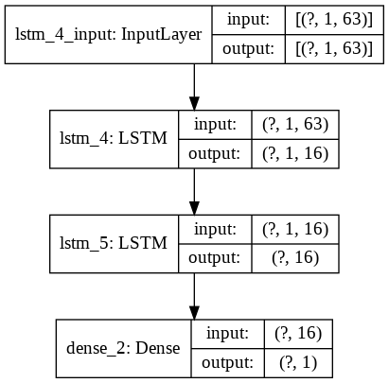

Figure 6: Shape of tensor of each layer of LSTM model

Table 4: Shape of tensor of the first and last layer of LSTM model

|  |  |
| --- | --- |
| **Input shape of tensor** | x_train: (36731, 1, 63) |
| x_test: (4591, 1, 63 ) |
| **Output shape of tensor** | y_train shape is (36731,16) |
| y_test shape is (4591,1) |

The LSTM model is built on a linear stack of layers with the sequential model. There are two hidden layers in total.

Figure 7: Summary of LSTM model.

For learning rate, I define a scheduler. When epoch is less than 10, the learning rate will be 0.01. When epoch is more then 10, it will decrease as epoch increase.

I apply early stopping with a patience 5 epochs, which means if the loss is not improving for 5 epochs, the training will stop. This policy can avoid unnecessary full training.

I try different hyperparameters, and combination of the best performance is Batch size 16, epochs 52 and without dropout.

Table 4: Performance comparison of different batch size

|  |  |  |  |
| --- | --- | --- | --- |
| **Batch size** | **16** | **32** | **64** |
| **Loss** | 0.2491 | 0.2668 | 0.2962 |
| **Accuracy** | 0.8883 | 0.8789 | 0.8624 |

Best batch size is 16.

Table 5: Performance comparison of different drop out

|  |  |  |  |
| --- | --- | --- | --- |
| **Drop out** | **none** | **0.1** | **0.5** |
| **Loss** | 0.2491 | 0.2884 | 0.2544 |
| **Accuracy** | 0.8883 | 0.8789 | 0.8801 |

The performance does not improve, so I removed dropout.

According to the above discussion, Hyperparameters of LSTM model are as follows:

|  |  |
| --- | --- |
| **Batch Size** | 16 |
| **Epochs** | 52 |
| **Dropout** | (unnecessary) |

A snippet of code of constructing the model/network is shown as follows:

Figure 8: Annotated code of LSTM model training

Training and Testing performance of LSTM model are as follows:

Figure 9: Training log of LSTM model training



Figure 10: Testing result of LSTM model

Figure 10: Performance of LSTM model training

Table 5: Test result of LSTM model

|  |  |
| --- | --- |
| **Testing Loss** | 0.1497 |
| **Testing Accuracy** | 0.9395 |
| **AUC** | 0.9805 |
| **Sensitivity /Recall**  **( $Sensitivity=\frac{TP}{TP+FN}$)** | 0.9486 |
| **Specificity**  **( $Specificity=\frac{TN}{TN+FP}$)** | 0.9095 |

After training the model and use test dataset to get the test score, I trained the final LSTM model using all the data.

Figure 11: Annotated code of LSTM model training using all data

## 3.2 CNN model Training

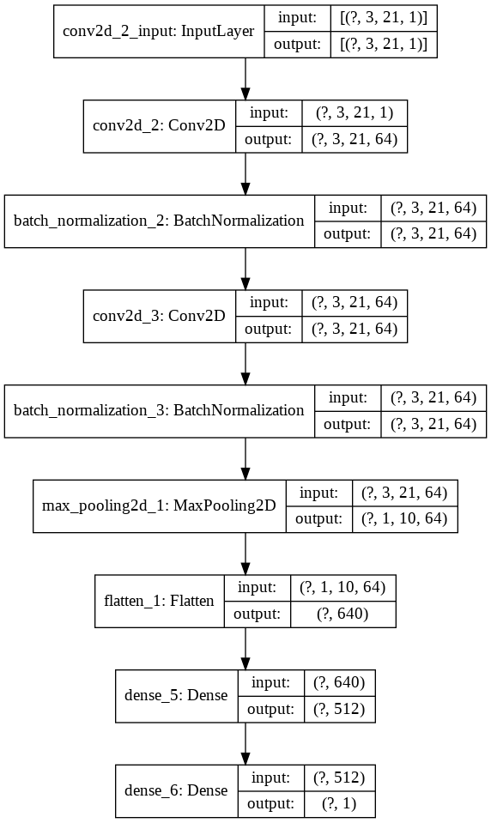

Figure 12: Shape of tensor of each layer of CNN model

Table 13: Shape of tensor of the first and last layer of CNN model

|  |  |
| --- | --- |
| **Input shape of tensor** | x_train: (36731, 3, 21, 63) |
| x_test: (4591, 3, 21, 1 ) |
| **Output shape of tensor** | y_train shape is (36731,512) |
| y_test shape is (4591,1) |

The CNN model is built on a linear stack of layers with the sequential model. There are 2 2D-convolution layers, 1 max pooling layers and 2 dense layers.

I added batch normalization between 2 convolution layers to adaptively normalize data as the mean and variance change over time during training.

Figure 14: Summary of CNN model.

According to the above discussion, Hyperparameters of CNN model are as follows:

|  |  |
| --- | --- |
| **Batch Size** | 16 |
| **Epochs** | 18 |
| **Dropout** | (unnecessary) |

For learning rate, I use the same scheduler as LSTM model. When epoch is less than 10, the learning rate will be 0.01. When epoch is more then 10, it will decrease as epoch increase.

I apply early stopping with a patience 5 epochs, which means if the loss is not improving for 5 epochs, the training will stop. This policy can avoid unnecessary full training.

I try different hyperparameters, and combination of the best performance is Batch size 16, epochs 22 and without dropout.

Table 12: Performance comparison of different batch size

|  |  |  |  |
| --- | --- | --- | --- |
| **Batch size** | **16** | **32** | **64** |
| **Loss** | 0.0667 | 0.0713 | 0.0812 |
| **Accuracy** | 0.9692 | 0.9621 | 0.9343 |

Best batch size is 16.

Table 13: Performance comparison of different drop out

|  |  |  |  |
| --- | --- | --- | --- |
| **Drop out** | **none** | **0.1** | **0.5** |
| **Loss** | 0.0667 | 0.0877 | 0.0670 |
| **Accuracy** | 0.9692 | 0.9601 | 0.9652 |

The performance does not improve, so I remove dropout.

Regarding the optimization of the network parameters, I found Adam is better than RMSprop here.

Table 14: Performance comparison of different optimizer

|  |  |  |
| --- | --- | --- |
| **Optimizer** | **Adam** | **RMSprop** |
| **Loss** | 0.0667 | 0.0877 |
| **Accuracy** | 0.9692 | 0.9601 |

A snippet of code of constructing the model/network is shown as follows:

Figure 15: Annotated code of CNN model training

Training and Testing performance of CNN models are as follows:

Figure 16: Training log of CNN model training



Figure 10: Testing result of CNN model

Figure 17: Performance of CNN model training

Table 5: Test result of CNN model

|  |  |
| --- | --- |
| **Testing Loss** | 0.0667 |
| **Testing Accuracy** | 0.9692 |
| **AUC** | 0.9928 |
| **Sensitivity / Recall**  **( $Sensitivity=\frac{TP}{TP+FN}$)** | 0.9795 |
| **Specificity**  **( $Specificity=\frac{TN}{TN+FP}$)** | 0.9332 |

After training the model and use test dataset to get the test score, I trained the final CNN model using all the data.

Figure 11: Annotated code of CNN model training using all data

## 3.3 Ensemble Model Training

The LSTM model and CNN model are good models and they prediction from different aspects. I ensemble these two models with different ratio and compare the performance(*Accuracy* = $\frac{\left(TruePositive+TrueNegative\right)}{ALLframes}$) of ensembled model and CNN model and LSTM model.

Table 11: Ratio of CNN model to LSTM model, *Accuracy* comparison

|  |  |  |  |
| --- | --- | --- | --- |
| **CNN vs. LSTM** | **Ensembled model** | **CNN model** | **LSTM model** |
| 0.1 : 0.9 | 0.9362491834 | 0.9611615891 | 0.9332501930 |
| 0.2 : 0.8 | 0.9399311122 |
| 0.3 : 0.7 | 0.9440287427 |
| 0.4 : 0.6 | 0.9496704079 |
| 0.5 : 0.5 | 0.9591127739 |
| 0.6 : 0.4 | 0.9606271156 |
| 0.7 : 0.3 | 0.9609240453 |
| 0.8 : 0.2 | 0.9611318961 |
| 0.9 : 0.1 | 0.9611318961 |

It is shown that ensembled model does not have improved the accuracy of prediction. Therefore, it seems unnecessary to do model ensembling. But in the last experiment(models trained without YOUTUBE dataset), with ratio 0.8: 0.2(CNN vs. LSTM) the ensembled model have better performance(0.9611318961933607)compare to CNN model(0.9611615891680029) and LSTM model(0.9332501930043352). Therefore, I decide to make the final model for prediction as ensembled model.

Figure 11: Annotated code of model ensembling

# Problems and Fail Cases

For all data I used, I use the final model(ensembled model) to get all fail cases. For a total of 33678 video frames, there are 1309 fail cases. In these fails frames, there are 1185 false-positive frames(actual fall but predicts not fall) 124 false-negative frames(actual not fall but predicts fall). For all these fail cases, I got a CSV file of their video number and frame number. I could analyze them by checking each frame.

Figure 11: Annotated code of getting fail cases

test_acc_emsembled_model.ipynb

By checking the image of fail video frames. I summarize main reasons of fail prediction.

Table 12: Reasons of fail prediction

|  |  |  |
| --- | --- | --- |
| **Fail reason** | **Number of fail frames** | **Percentage** |
| Uncertainty of falling action | 610 | 46.6% |
| Confusing actions | 431 | 32.9% |
| Uncertain reason | 268 | 20.5% |

First, the uncertainty of falling action. These fail cases happen before the fall and are consider as fall. The main reason for this failure is because the trimming and labeling of videos.

UR dataset has a label for each frame, but the Multiple Camera Dataset does not have. Then I trimmed each video into 2 parts: the first part is before fall(the person may walk, sit or stand) and the second part is falling and laying on the floor. I labeled all frames of the first part to be 0(not fall) and all frames of the second part to be 1(fall). The trimming is judge by a human, and the fall action is a consecutive action. Therefore, there is no exact time to trim the video. For example, the frame image below shows a person is leaning and about to fall. I trimmed the video at this moment. However, these two frames will have every similar body landmark data.

Figure 11: Vdeo 59 from Multiple Camera Dataset

Left frame: marked as fall;

Right frame: marked as not fall

Second, not enough data for confusing actions.

The actor performs confusing actions. For example, laying on the sofa bending to seek objects under the sofa or grabbing an object on the floor. There are some videos contains confusing actions for training, but not enough. Then the network does not have enough samples to learn.

Videos from YOUTUBE dataset improved the performance by adding videos of real video of old people falling in the hospital or people falling outdoor. However, it is still not enough videos. Fall is a dangerous and not fun action, there are not many videos could be found from the internet and it also hurts to trying make fall video by myself.

If there are enough video data of different kinds of fall and confusion actions, my training structure will get a more precise model.

Third, other uncertain reasons.

I did not know the exact reason of other fail predictions. It could be the limitations of the cameras and the body landmark extraction algorithm.

The UR dataset only has two camera positions (parallel to the floor and ceiling-mounted, respectively). The video from ceiling mounted cannot generate body landmark, so I only use video recorded by camera parallel to the floor. Though the Multiple Camera Dataset contains 8 cameras from different positions, there are only 22 videos contains fall. Videos from YOUTUBE dataset has different angles but there are only 46 videos of this dataset. Therefore, there is not enough video from different positions for training. The body landmark extraction also has its limitations and cannot be 100% accurate.

# Smart Home Solution

I found that for every 30 frames of each video, there are less than 10 consecutive fail frames. Therefore, for a real application, the problem of fail prediction can be solved by for every 30 frames(for video, 30 frames would be 1 second), the prediction of fall or not fall could be decided by the mode of predictions of these 30 frames.

# Annotated Code

# Instruction of Using Models

# Reference

[1] Bogdan Kwolek, Michal Kepski, Human fall detection on embedded platform using depth maps and wireless accelerometer, Computer Methods and Programs in Biomedicine, Volume 117, Issue 3, December 2014, Pages 489-501, ISSN 0169-2607.

[2] E. Auvinet, C. Rougier, J.Meunier, A. St-Arnaud, J. Rousseau, Multiple cameras fall dataset, Technical report 1350, DIRO - Université de Montréal, July 2010.

[3] Z. Cao, G. Hidalgo Martinez, T. Simon, S. Wei, Y. A. Sheikh, OpenPose: Realtime Multi-Person 2D Pose Estimation using Part Affinity Fields, IEEE Transactions on Pattern Analysis and Machine Intelligence, 2019.

[4] Tomas Simon, Hanbyul Joo, Iain Matthews, Yaser Sheikh, Hand Keypoint Detection in Single Images using Multiview Bootstrapping, 2017.

[5] Zhe Cao, Tomas Simon, Shih-En Wei, Yaser Sheikh, Realtime Multi-Person 2D Pose Estimation using Part Affinity Fields, 2017

[6] Shih-En Wei, Varun Ramakrishna, Takeo Kanade, Yaser Sheikh, Convolutional pose machines, 2016

[7]